Linux Boot Process: Stage by Stage

Stage 1: BIOS / UEFI
Role: Firmware on the motherboard that initializes hardware and bridges to software.
Responsibilities:
- POST (Power-On Self-Test): Check CPU, RAM, storage, and peripherals. Signals errors if hardware fails.
- CMOS: Load system settings (time, date, configuration).
- Boot Device Selection: Scan bootable devices and locate:
  - BIOS: MBR (Master Boot Record)
  - UEFI: EFI System Partition (ESP)
- Hand over control: Pass booting to the bootloader (e.g., GRUB2).
Key Point: Ensures hardware is ready for OS loading.

Stage 2: MBR (Master Boot Record)
Role: Small program (512 bytes) at the first sector of the boot device.
Responsibilities:
- Contains bootloader code (446 bytes), partition table (64 bytes), validator (2 bytes).
- Locates the next boot stage (GRUB).
- Passes control to GRUB if intact; otherwise, triggers “GRUB error.”
Key Point: Guides the system to the bootloader and informs about disk partitions.

Stage 3: GRUB (Grand Unified Bootloader)
Role: Bootloader that loads the Linux kernel and initramfs.
Responsibilities:
- Display boot menu with all installed kernels.
- Allow interactive kernel selection or boot default automatically.
- Load kernel and initramfs into memory.
- Manage configuration via:
  - /boot/grub2/grub.cfg → main settings
  - /etc/default/grub → default option

Key Point: Provides flexibility to choose kernels and starts the Linux kernel.
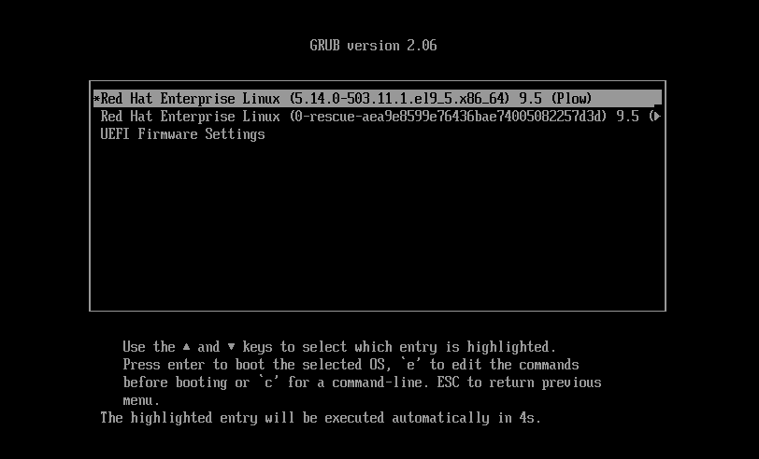

Stage 4: Kernel Loading and Initialization
Role: Core of Linux; manages hardware, drivers, and communication with software.
Responsibilities:
- Load Drivers and Modules: Use initramfs (temporary filesystem in /boot) to load essential drivers early.
- Hardware Detection: Identify CPU, RAM, disks, network, and graphics devices.
- Mount Root Filesystem: Initially read-only; then switch to full read/write.
- Start First User-space Process: Launch systemd (PID 1 in modern Linux) or init (older systems).
Failure Points:
- Missing initramfs → boot fails → recovery with dracut.
- Bad /etc/fstab or corrupt FS → kernel panic.
Key Point: Prepares the system for user-space initialization

Stage 5: Init / Systemd and Targets
Role: First user-space process (PID 1) that manages services and system state.
Responsibilities:
Standard Run Levels (0-6):
- 0: Halt: Shuts down the system completely. All processes are terminated, and power is typically cut off.
- 1: Single-User Mode:
  - Provides a command-line interface without network configuration or daemons.
  - Primarily used for system maintenance, troubleshooting, and critical repairs.
  - Only root or users with specific permissions can log in.
- 2: Multi-User Mode without NFS:
  - Starts the system with multiple users but without the Network File System (NFS).
  - Useful when NFS is not required or may cause instability.
- 3: Multi-User Mode with Networking:
  - The default run level for many systems.
  - Provides a full multi-user environment with networking enabled.
  - Most services and daemons are started.
- 4: Undefined:
  - Typically reserved for user-defined configurations.
  - Not commonly used in modern systems.
- 5: X11:
  - Similar to run level 3 but also starts a graphical display manager (X11).
  - Provides a graphical user interface for the system.
- 6: Reboot:
  - Restarts the system.
  - All processes are terminated, and the system reboots into the default run level.

- Start Services/Daemons: Networking, logging, FTP, Samba, LVM, NFS, etc.
- Manage Filesystems: Mount additional partitions as needed (/home, /var, swap).
- Change Targets if Needed: systemctl set-default <target>
Key Point: Prepares the system for user interaction based on the desired target.
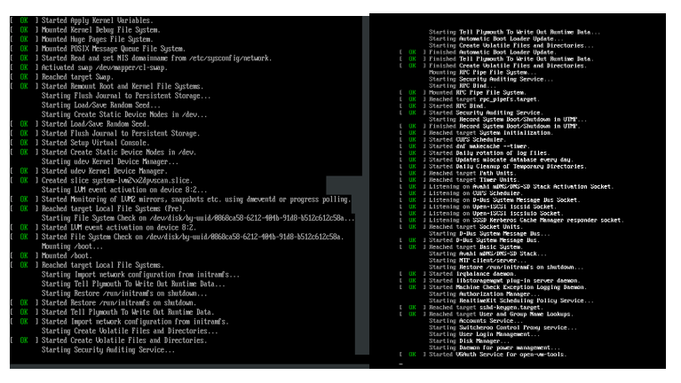

Stage 6: User-space Processes and Login
Role: Allow the user to interact with the system.
Responsibilities:
- Start login manager (CLI and GUI).
- Authenticate user credentials via PAM.
- Start user session (shell for CLI, desktop environment for GUI).
- Load user-specific settings and applications.
Key Point: The System is fully operational and ready for the user.
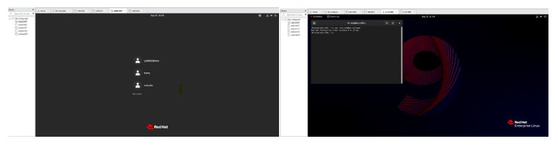

Visualizing the Linux Boot Process Key Points to Remember:
- The Linux boot process is a collaborative effort between hardware, firmware, and software components.
- Each stage builds upon the previous one, ensuring a smooth and reliable system startup.
- The boot process can be customized and configured to suit specific system requirements.

